Lab 8: Part 2
Name: Abdirahim Abdullahi
Course: INET 4031
Date: 11/30/2025

Step 1 – GitHub Repository
SUBMISSION 1
Repository Link:
https://github.com/abdirahim104/inet_4031_adduser_script

Step 2 – create-users.py Added
SUBMISSION 2
Question:
What would your reaction be if your boss handed you this uncommented script and told you to make it work?
Answer:
Honestly, I would feel a bit overwhelmed and frustrated at first. I could eventually figure out what the code does by reading it line by line, but it would take longer and I’d worry about misinterpreting the logic. I’d definitely wish there was at least some basic documentation or comments so I could be confident I was using it the way my boss actually intended.

Step 3 – create-users.input Analysis
SUBMISSION 3
Answer BOTH questions:
- How does the code handle a line that doesn’t have enough fields?
The code splits each line using fields = line.strip().split(':') and then checks if match or len(fields) != 5:. If the line does not have exactly five fields, the condition is true and the script immediately does continue, which skips that line and moves on to the next one. This prevents invalid or incomplete lines from being processed.

- How can a user indicate that a line should be skipped? What detects this in the code?
A user can mark a line to be skipped by starting it with a # character. The script uses a regular expression match = re.match("^#", line) to check if the line begins with #. If it does, match is not None, and the condition if match or len(fields) != 5: is true, causing the script to skip that line and not try to create a user from it.

Step 4 – Dry Run Output
SUBMISSION 4
Paste the full terminal output of:
./create-users.py < create-users.input
Dry Run Output:
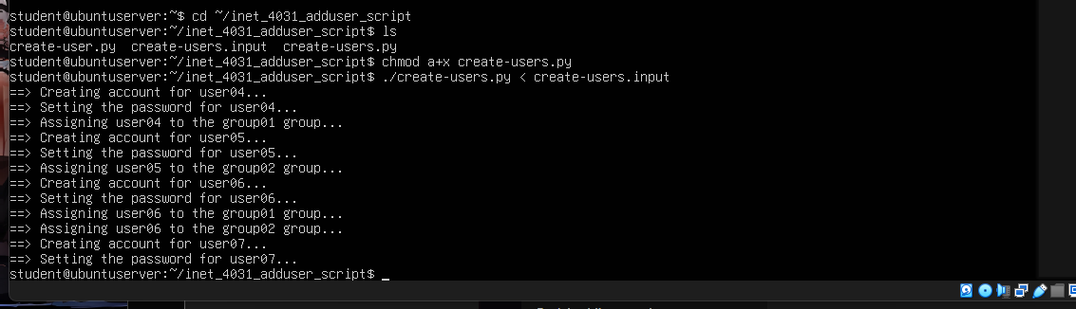

Step 4 – Dry Run Questions
SUBMISSION 5
Answer ALL FOUR questions:
- Purpose of #!/usr/bin/python3
The line #!/usr/bin/python3 is a “shebang” that tells Linux which interpreter to use when the script is executed. It lets me run the script with ./create-users.py and have it automatically use the Python 3 interpreter without typing python3 explicitly.
- Can we run the script like this?:
sudo python create-users.py < create-users.input
Yes, that would work too. In that case we’re calling the Python interpreter directly and passing the script as an argument. The shebang line is not required when we run it that way, but using ./create-users.py with the shebang is more idiomatic and makes the script behave like a normal executable program.
- What does the < symbol do?
The < symbol is input redirection. It takes the contents of the create-users.input file and feeds it into the script as standard input (stdin), as if each line in the file were being typed into the program. This allows the script to read the file line by line without having to open it directly with Python’s open().
- How are lines from the input file getting into the Python code?
Inside the code, there is a loop like for line in sys.stdin:. Because of the < create-users.input redirection, sys.stdin is connected to the file, not the keyboard. That means each iteration of the loop reads one line from create-users.input, so every user definition in the file is processed one at a time by the script.

Step 5 – Real Run Verification
SUBMISSION 6
Insert TWO screenshots:
- Screenshot of:
- grep user0 /etc/passwd
- Screenshot of:
- grep user0 /etc/group
Screenshot 1:
Screenshot 2:
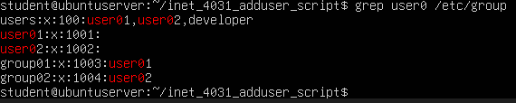Step 5 – grep Explanation
SUBMISSION 7
Question:
What is the purpose of the grep command above? Why did it print the results that it did?
Answer:
The grep command searches for text patterns inside a file. The command grep user0 /etc/passwd prints all user accounts that start with “user0”, which verifies that the script created those entries. The command grep user0 /etc/group does the same for group memberships, confirming that the users were correctly added to their groups.

Step 6 – Well Documented Code

Step 7 – create-users2.py Dry Run & Real Run
SUBMISSION 9
We talked in class about my struggle with getting a file push out in the vm to my github due a struggle with the token login. No matter how many times I changed the token and put it back in it wouldn’t work. You told me to skip this part, since I cant login into my github on the vm

